**AUTOMATED WHITE BOX UNIT TESTING DOCUMENTATION ON**

**SIMPLE BANKING ALGORITHM**



OLEH :

Wahyu Riyan Hidayat 082111633079

**S1 SISTEM INFORMASI**

**FAKULTAS SAINS DAN TEKNOLOGI**

**UNIVERSITAS AIRLANGGA**

**SOURCE CODE**

[wahyurh/Automated-WhiteBox-Unit-Test: This repository contain automated unittest on simple banking algorithm. - https://github.com/wahyurh/Automated-WhiteBox-Unit-Test](https://github.com/wahyurh/Automated-WhiteBox-Unit-Test)

**OVERVIEW**

The code above is a simple banking program with basic functionalities such as creating a bank account, log in, deposit money, withdraw money, check account balance, and transferring money between accounts. There are 8 functions in this code :

1. Generate_account_number function



This function used to generate random 5 digits integer number for account number. This function doesn’t take a parameter so every time it called this function only generate random 5 digits number and convert the output into string.

1. Create_bank_account function

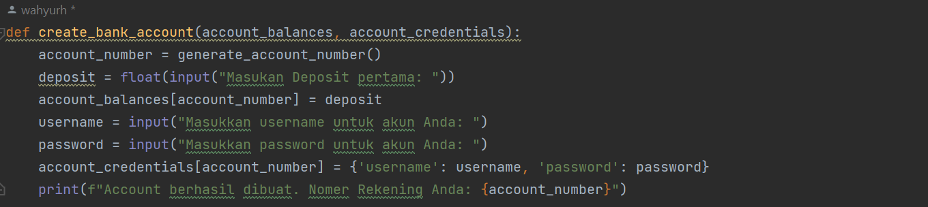This function is responsible for creating a new bank account by generating a unique account number. There are two parameters used in this function (account_balances and account_credentials). This function first called generate_account_number function to create unique number as new bank account number. Then it take user input (number) to

1. Login function

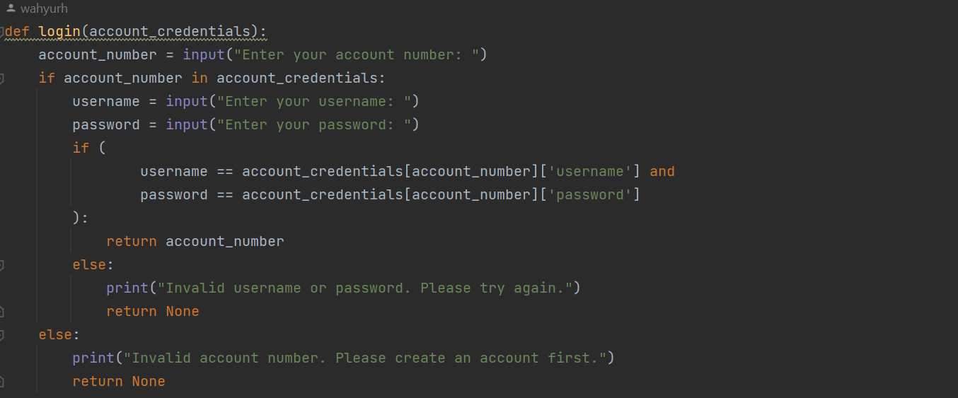

1. Deposit function

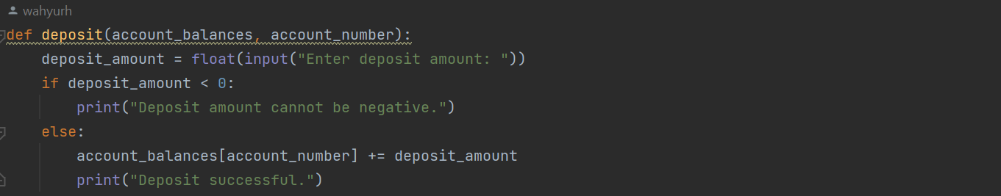

1. Withdrawal function

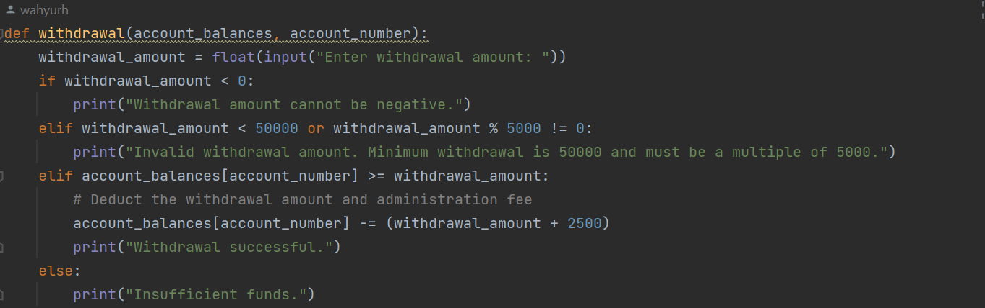

1. Check_balance function



1. Transfer function

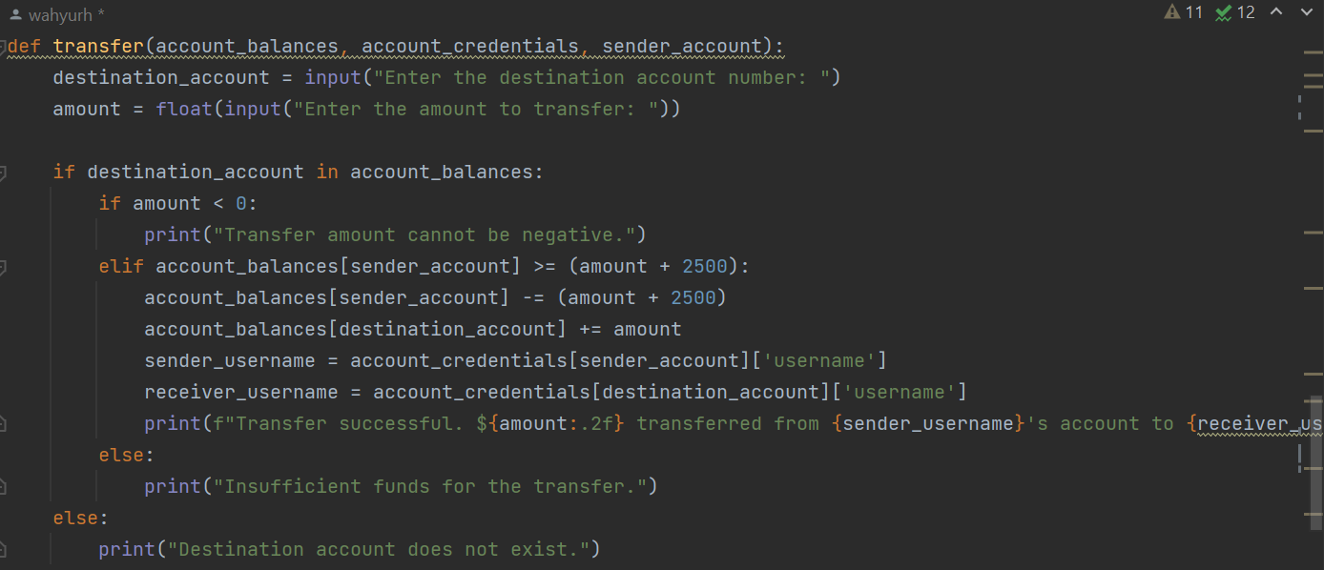

1. Main function
2. def main():  
    # Open the shelf files for persistent storage  
    with shelve.open("bank_accounts") as account_balances, shelve.open("account_credentials") as account_credentials:  
    print("\nBanking Menu:")  
    print("1. Create Bank Account")  
    print("2. Login")  
    print("3. Exit")  
    choice = input("Enter your choice (1-3): ")  
    if choice == '1':  
    create_bank_account(account_balances, account_credentials)  
    elif choice == '2':  
    account_number = login(account_credentials)  
    if account_number is not None:  
    print("\nBanking Options:")  
    print("1. Deposit")  
    print("2. Withdrawal")  
    print("3. Check Account Balance")  
    print("4. Transfer")  
    banking_choice = input("Enter your choice (1-4): ")  
    if banking_choice == '1':  
    deposit(account_balances, account_number)  
    elif banking_choice == '2':  
    withdrawal(account_balances, account_number)  
    elif banking_choice == '3':  
    check_balance(account_balances, account_number)  
    elif banking_choice == '4':  
    transfer(account_balances, account_credentials, account_number)  
    else:  
    print("Invalid choice. Please enter a number between 1 and 4.")  
    elif choice == '3':  
    print("Exiting the banking program. Goodbye!")